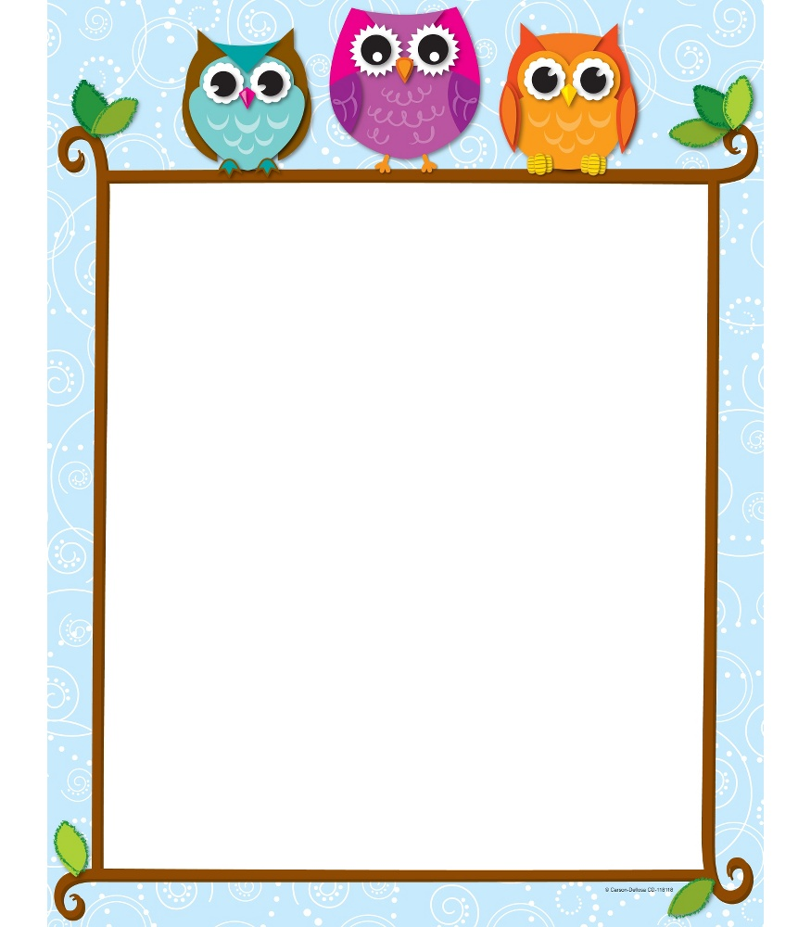

September 3, 2014

Dear Parents/ Guardians,

Welcome to the Open House at Hillsborough Elementary School! I am very excited to start a new school year with your child. The first day of school is tomorrow and there are important details of our daily schedule and routines for you to know:

* Every day we will have a 10-minute snack. Our classroom is an Allergy Aware Room! There are several students in your child’s classroom that have a severe allergy to peanuts, nuts, shellfish and latex. It is important that there is strict avoidance in order to prevent a life-threatening allergic reaction. Please help us to provide these students with a safe school environment. Any exposure to nuts, shellfish and latex may cause a life-threatening allergic reaction that requires emergency medical treatment. Please do not send any peanut or nut containing products to school with your child. If your child has eaten peanuts/nuts before coming to school, be sure your child’s hands and face have been thoroughly washed before entering the school.
* Please pack a healthy snack and drink. It is best to send your child with a snack that is easy to open. Place your child’s snack in a brown bag or snack box labeled with his/her name. White milk and chocolate milk may be purchased daily for 25 cents. I will update you as to when your child may begin to purchase a drink.
* We operate on a six-day cycle. Days rotate only on the days we are in school. For example, if Monday is Day 1 and there is no school on Tuesday, Wednesday would be Day 2. Gym is scheduled once a cycle, and the children are required to wear sneakers.
* We love celebrating birthdays! Due to many food allergies, district policy discourages birthday treats. In lieu of treats, you may send in one non-food item such as pencils, bookmarks, inexpensive toys, etc. We also welcome the opportunity for you to come in and read a story for your child’s birthday. If your child has a summer birthday, don’t worry we’ll celebrate before the end of the year!
* Every day your child will bring home their Take Home folder. I place school notices, teacher notes, completed work and homework in this folder. Please check the folder daily. Return the folder each day and include any correspondence and homework for my attention.

I am very excited for the coming year and truly look forward to working with you and your child! We are going to have a wonderful year! If you have any additional questions or concerns, please don’t hesitate to contact me. Enjoy the rest of your summer!

Sincerely,

Miss Visicaro